ASSIGNMENT 7

NAME: AAVIRAJ NIKUMBH
PRN:24070126123
BATCH: AIML B2
Link - https://github.com/AaviRaj1702/Java_Files
CODE:
import java.io.*;
import java.util.*;

public class StudentsCRUD {

static String fileName = "Students.csv";

public static void main(String[] args) {

try {
createFile();
addInitialRows();
addMoreRows();
updateMarks();
calculatePercentage();
deleteRow(2); // delete 2nd student
displayFile();

// Demonstrate Exception
demonstrateException();

} catch (IOException e) {
System.out.println("Exception occurred: " + e.getMessage());
}
}

// 1. Create File with Header
public static void createFile() throws IOException {
FileWriter fw = new FileWriter(fileName);
fw.write("studentId,name,branch,marks1,marks2,marks3,marks4,marks5,percentage\n");
fw.close();
System.out.println("File created with header.");
}

// 2. Add Initial Rows
public static void addInitialRows() throws IOException {
FileWriter fw = new FileWriter(fileName, true);

fw.write("1,John,CSE,80,85,90,0,0,0\n");
fw.write("2,Alice,IT,75,70,80,0,0,0\n");

fw.close();
System.out.println("Initial rows added.");
}

// 3. Add 3 More Rows
public static void addMoreRows() throws IOException {
FileWriter fw = new FileWriter(fileName, true);

fw.write("3,Bob,ECE,60,65,70,0,0,0\n");
fw.write("4,Emma,MECH,88,92,85,0,0,0\n");
fw.write("5,Raj,CSE,78,82,80,0,0,0\n");

fw.close();
System.out.println("3 more rows added.");
}

// 4. Update Marks (marks4 & marks5)
public static void updateMarks() throws IOException {
List<String[]> data = readFile();

for (int i = 1; i < data.size(); i++) {
String[] row = data.get(i);

row[6] = String.valueOf(70 + i); // marks4
row[7] = String.valueOf(75 + i); // marks5
}

writeFile(data);
System.out.println("Marks updated.");
}

// 5. Calculate Percentage
public static void calculatePercentage() throws IOException {
List<String[]> data = readFile();

for (int i = 1; i < data.size(); i++) {
String[] row = data.get(i);

int sum = 0;
for (int j = 3; j <= 7; j++) {
sum += Integer.parseInt(row[j]);
}

double percentage = sum / 5.0;
row[8] = String.format("%.2f", percentage);
}

writeFile(data);
System.out.println("Percentage calculated and updated.");
}

// 6. Delete Row
public static void deleteRow(int rowNumber) throws IOException {
List<String[]> data = readFile();

if (rowNumber < data.size()) {
data.remove(rowNumber);
writeFile(data);
System.out.println("Row " + rowNumber + " deleted.");
} else {
System.out.println("Row not found.");
}
}

// Read CSV
public static List<String[]> readFile() throws IOException {
List<String[]> data = new ArrayList<>();
BufferedReader br = new BufferedReader(new FileReader(fileName));

String line;
while ((line = br.readLine()) != null) {
data.add(line.split(","));
}

br.close();
return data;
}

// Write CSV
public static void writeFile(List<String[]> data) throws IOException {
FileWriter fw = new FileWriter(fileName);

for (String[] row : data) {
fw.write(String.join(",", row) + "\n");
}

fw.close();
}

// Display File
public static void displayFile() throws IOException {
System.out.println("\nFinal File Content:");

BufferedReader br = new BufferedReader(new FileReader(fileName));
String line;

while ((line = br.readLine()) != null) {
System.out.println(line);
}

br.close();
}

// 7. Demonstrate Exception Handling
public static void demonstrateException() {
try {
BufferedReader br = new BufferedReader(new FileReader("WrongFile.csv"));
br.readLine();
br.close();
} catch (IOException e) {
System.out.println("\nException Demonstrated Successfully:");
System.out.println(e);
}
}
}

OUTPUT:
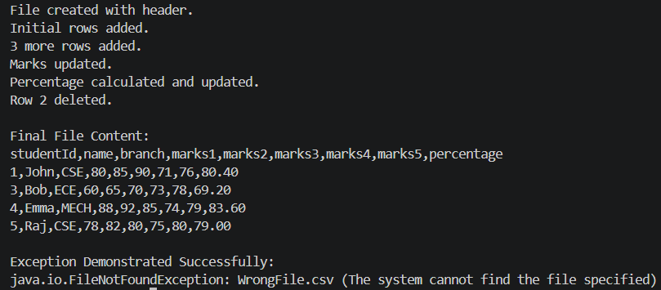

REPOSITORY LINK :
https://github.com/Aaviraj-hub-Nikumbh/Java-Lab-Assignments.git

